OUTPUT:

10a. CONSTRUCT DNN MODEL FOR LOAD_IRIS DATASET

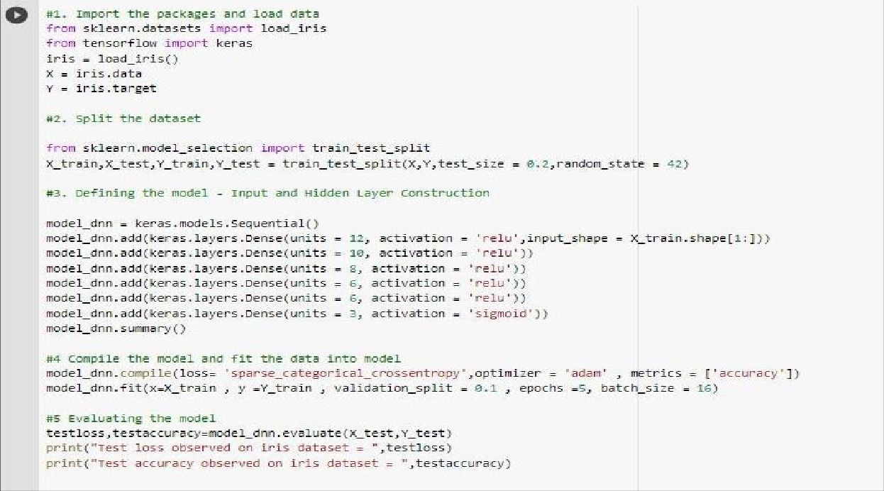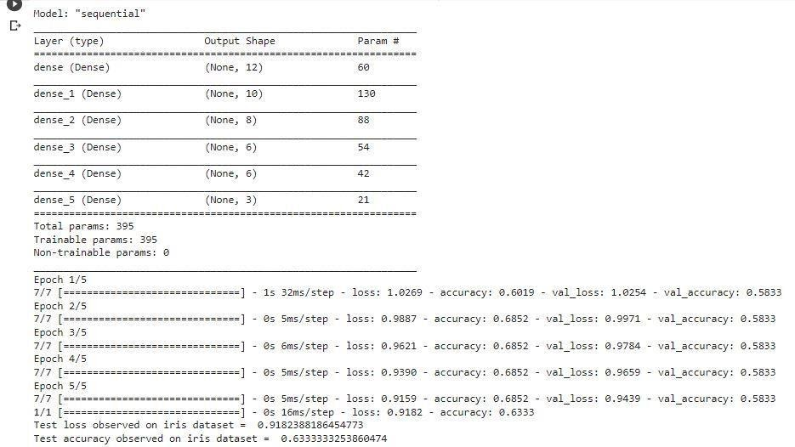

10b. CONSTRUCT DNN MODEL FOR LOAD_IRIS DATASET AND PERFORM DL STRATEGIES

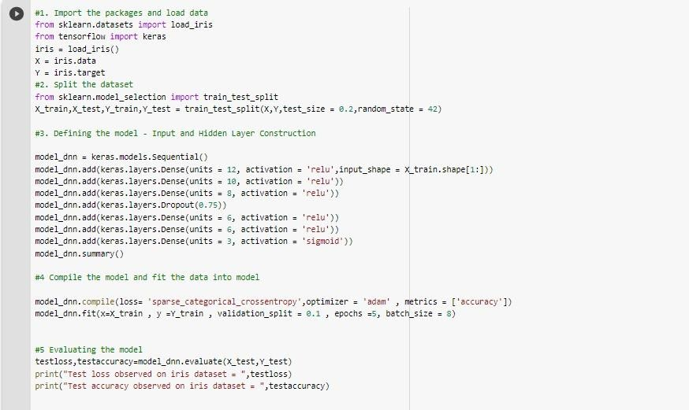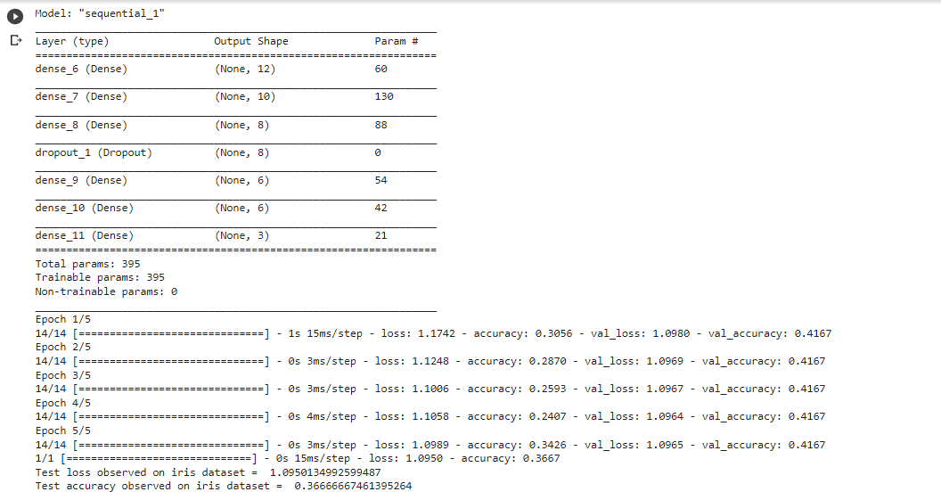

10c. CONSTRUCT DNN MODEL FOR LOAD_WINE DATASET AND PERFORM DL STRATEGIES

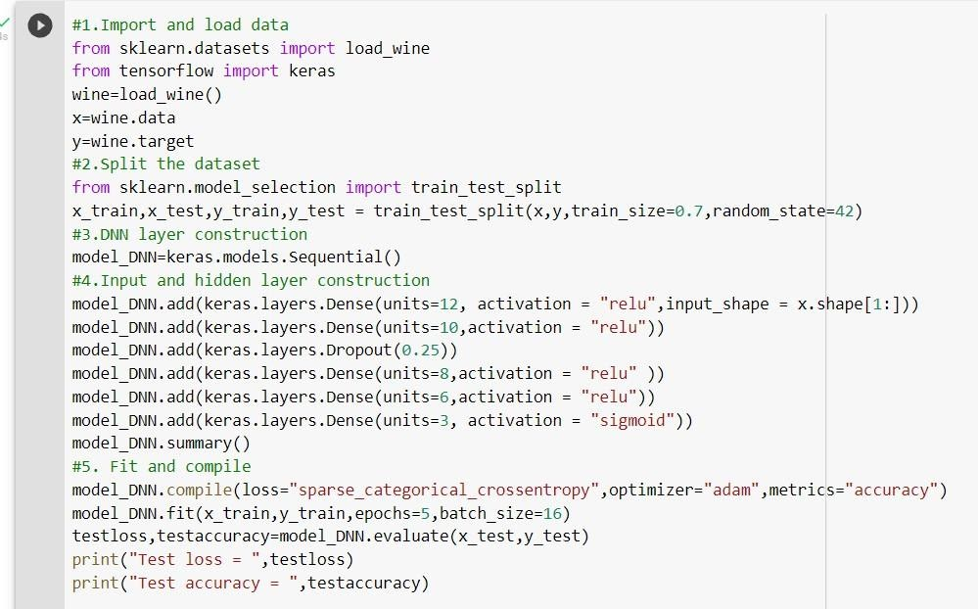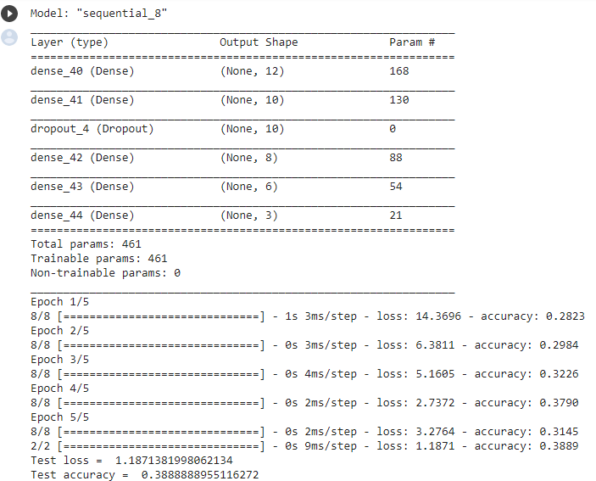

10d. CONSTRUCT DNN MODEL FOR FOREST COVER DATASET AND PERFORM DL STRATEGIES

